A Progress Report

on

Image To Text Converter with Language Translation

carried out as part of the course: AI2270
Submitted by
Mokshika Pandey
(229310297)

IV-AIML

in partial fulfilment for the award of the degree

of

BACHELOR OF TECHNOLOGY

In

Computer Science and Engineering (AIML)

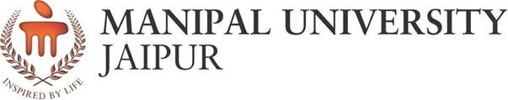

Department of Artificial Intelligence and Machine Learning
School of Computer Science & Engineering
Manipal University Jaipur,
March 2022

Acknowledgement

This project would not have completed without the help, support, comments, advice, cooperation and coordination of various people. However, it is impossible to thank everyone individually; I am hereby making a humble effort to thank some of them.

I acknowledge and express my deepest sense of gratitude of my internal supervisors Dr Puneet Mittal and Dr Preeti Narooka for their constant support, guidance, and continuous engagement. I highly appreciate their technical comments, suggestions, and criticism during the progress of this project “Image to text converter with language translation”.

I owe my profound gratitude to Santosh Vishwakarma Sir, Head, Department of CSE(AIML), for his valuable guidance and facilitating me during my work. I am also very grateful to all the faculty members and staff for their precious support and cooperation during the development of this project.

Finally, I extend my heartfelt appreciation to my classmates for their help and encouragement.

Mokshika Pandey- 229310297



Department of Computer Science and Engineering
School of Computing & Information Technology

Date: 15-4-2024

CERTIFICATE

This is to certify that the project entitled “IMAGE TO TEXT CONVERTER WITH LANGUAGE TRANSLATION" is a bonafide work carried out as Project Based Learning (Course Code: AI2270) in partial fulfillment for the award of the degree of Bachelor of Technology in CSE-AIML, under my guidance by Mokshika Pandey bearing registration number 229310297, during the academic semester VI of year 2022-23.

Place: Manipal University Jaipur, Jaipur

Name of the project guide: Dr.Puneet Mittal and Dr.Preeti Naruka

Signature of the project guide: ______________________

ABSTRACT

This project introduces a concise method for image-to-text conversion and language translation using the EasyOCR and Translate libraries in Python. By combining EasyOCR's efficient text extraction with Translate's language translation capabilities, the system provides a straightforward solution for converting images to text and translating it into multiple languages. Experimental results demonstrate the systems effectiveness making it ideal for diverse applications such as multilingual content generation and accessibility aids.

In summary, the integration of EasyOCR and Translate libraries presents a straightforward yet powerful solution for image-to-text conversion with language translation, catering to the needs of diverse users in today's interconnected world.

Contents
Page no.
Acknowledgement 2
Certificate 3
Abstract 4
- Introduction
  - Objective of the project 6
  - Brief description of the project 7
  - Literature review 8-9
  - Technology used 10
    - H / W Requirement
    - Software Requirement
- Design Description
  - Flow Chart 11
  - Data Flow Diagrams(DFDs) 12
  - Entity Relatoinship Diagram(E-R Diagram) 13
- Project Description
  - Data Base 14
  - Table Description 15
- Input/Output Form Design 16
- Future scope 17-18
- Conclusion 19
- Bibliography 20

INTRODUCTION

  - Objective of the project:
The primary objective of this project is to develop a streamlined system for image-to-text conversion with integrated language translation capabilities. Specifically, we aim to:

1. Utilize the EasyOCR library to accurately extract text from images, overcoming challenges such as varying fonts, sizes, and orientations.
2. Integrate the Translate library to translate the extracted text into multiple languages, facilitating cross-linguistic communication and accessibility
3. Evaluate the performance of the system in terms of accuracy, efficiency, and usability across diverse datasets and languages.
4. Explore potential applications of the system in fields such as multilingual content generation, language learning, and accessibility aids.

By achieving these objectives, we aim to provide a practical and versatile solution for converting visual information into textual content and facilitating language translation, thereby enhancing communication and accessibility in an increasingly interconnected world.

  - Brief description of the project:

Our project focuses on the development of a simplified system for image-to-text conversion and language translation, Leveraging the EasyOCR and Translate libraries in Python, we aim to streamline the process of extracting text from images and translating it into multiple languages.

The system begins by utilizing EasyOCR's robust optical character recognition capabilities to accurately extract text from images. This step addresses challenges such as varying fonts, sizes, and orientations, ensuring reliable text extraction across diverse visual content.

Once the text is extracted, the system seamlessly integrates the Translate library to translate it into the desired languages. This integration enables users to obtain textual descriptions in multiple languages, facilitating cross-linguistic communication and accessibility.

Throughout the project, we conduct rigorous evaluations to assess the system's performance in terms of accuracy, efficiency, and usability across diverse datasets and languages. Additionally, we explore potential applications of the system in fields such as multilingual content generation, language learning, and accessibility aids.

Overall our project aims to provide a practical and versatile solution for converting visual information into textual content and facilitating language translation.

  - Literature Review:

The survey work by Pooja Sharma et al. provides insights into document scanning, quality assessment methods, and metrics for document images. Additionally, web application translation using Python libraries and Google Translator exemplifies text translation across languages. This process involves several steps such as preprocessing, character recognition, segmentation, text extraction, detection, and translation, ultimately leading to image enhancement and improved text recognition. However, text recognition poses challenges as OCR technology is not 100% accurate, necessitating human inspection. Zeev Zelavsky et al. proposed a fuzzy logic-based algorithm for recognizing distorted text, focusing on calligraphic text in the Bible. Similarly, Badawy et al. worked on automatic license plate recognition (ALPR), extracting vehicle information from number plates for various applications like toll payment and traffic surveillance. Text recognition through Optical Character Recognition (OCR) systems plays a crucial role, with Shyam G. Dafe et al. outlining the steps involved in such systems. Overall, these studies contribute to advancing text recognition technology and its applications across various domains.

Another survey presents various advancements and methodologies in Optical Character Recognition (OCR) systems, particularly for camera-captured image documents and handheld devices. Key contributions include text region extraction, skew correction, binarization, segmentation, and character recognition modules. Techniques such as fuzzy logic, neural networks, and wavelet transform are utilized to enhance recognition accuracy. Additionally, innovative approaches like particle swarm optimization and adaptive neuro-fuzy inference systems are explored. The focus extends beyond character recognition to address challenges like handwritten character recognition, and multi-resolution techniques. Furthermore applications such as document scanning, information retrieval, and language translation are highlighted, underscoring the versatility and practical utility of OCR systems in various domains.

The surveys mentioned above provide comprehensive overview of Optical Character Recognition (OCR) systems, focusing on various aspects such as methodology, advancements, challenges, and applications. While our project shares some similarities with these surveys in terms of utilizing OCR technology. Our project specifically targets the integration of OCR with language translation, particularly for image-to-text translation with subsequent language translation. Unlike the surveys, which provide broad coverage of OCR techniques and applications, our project has a narrower focus on a specific application domain.

While the surveys discuss a wide range of methodologies used in OCR systems, our project may employ specific OCR libraries or APIs tailored for image-to-text conversion. Additionally we integrate language translation functionality, which may involve separate translation APIs or libraries. Our project may introduce innovative approaches or techniques to address the challenges of image-to-text translation and language translation These innovations could include optimization strategies, deep learning architectures, or novel algorithms tailored for our specific application domain.

Unlike other surveys which provide an overview of existing research and methodologies, our project aims to implement a practical solution for image-to-text translation with language translation capabilities. This involves integrating OCR and translation functionalities into a user-friendly application or workflow and unlike other surveys we implement our technology on Scene text images(natural images) and with refinements in our code and a proper well trained model we can surely implement it on real time images

In conclusion, our project represents a convergence of cutting-edge technologies aimed at breaking down language barriers and enhancing accessibility to information in the digital age. With further refinement and optimization, we envision our solution making meaningful contributions across various domains, including education, healthcare, and communication, ultimately empowering individuals to interact with textual content in a more inclusive and efficient manner.

  - Technology used:

    - HARDWARE REQUIREMENTS-

Personal computer or laptop with sufficient processing power to run Python scripts and libraries.

    - SOFTWARE REQUIREMENTS-

- Python programming language (version 3.x).

- EasyOCR library for optical character recognition.

- Translate library for language translation.

- Integrated Development Environment (IDE) such as PyCharm, Jupyter Notebook, or Visual Studio Code for coding and development.

- Operating system: Compatible with Windows, macOS, or Linux distributions.

DESIGN DESCRIPTION

2.1 Flowchart:
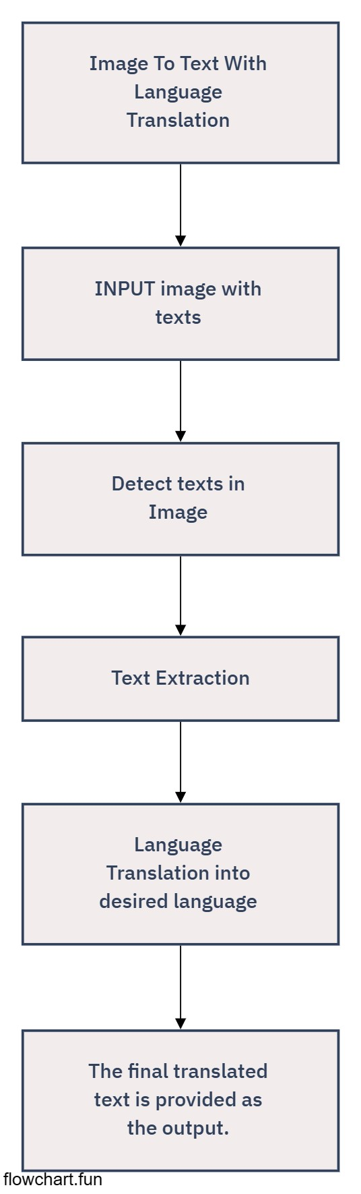

2.2 Data Flow Diagrams:
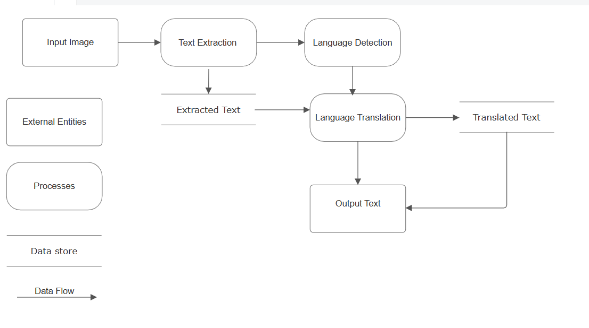

2.2 E-R DIAGRAM:

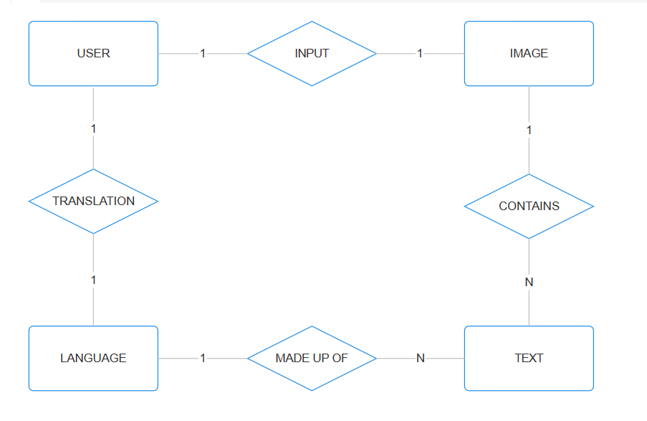

PROJECT DESCRIPTION
3.1 DATABASE:

The database for the project is in the form of a parquet file.
Parquet is a columnar storage format commonly employed in big data processing ecosystems like Apache Hadoop. It efficiently stores structured data, including input images, extracted text, detected languages, and translated text, optimizing storage and query performance. Parquet supports compression techniques, reducing storage requirements, and facilitates columnar processing, accelerating analytical workloads. Additionally, its seamless integration with big data frameworks enables easy incorporation into existing data processing pipelines. Overall, leveraging Parquet enhances scalability, efficiency, and compatibility for managing and analysing diverse data components within your project.

3.2 Table Description:

Image Data Table:
Columns:
1. ImageID: Unique identifier for each image.
2. ImagePath: File path or reference to the location of the image.
3. UploadDateTime: Timestamp indicating when the image was uploaded.

Extracted Text Table:
Columns:
1. TextID: Unique identifier for each extracted text.
2. ImageID: Foreign key referencing the Image Data Table, indicating the associated image.
3. ExtractedText: The extracted text from the image.
This table structure allows you to efficiently store and manage the various components of your project, including input images, extracted text, detected languages, and translated text, within the Parquet format.

4. Input/Output Design Format:
Input Format:
The input will be provided to the model in the form of a parquet file. The file contains around 21,500 images from which user can choose any image to test the model.

Output Format:
For text detection the user gets the image back with red boxes on the detected texts and for the language translation part the user gets the ouput where he/she can see the original text and the translated text.

FUTURE SCOPE

1. Improved Image Preprocessing Techniques:
Research and implement advanced image preprocessing techniques to further enhance the accuracy of text extraction, especially in challenging conditions like low lighting or skewed angles.

2. Enhanced Language Detection:
Integrate more sophisticated language detection algorithms to accurately identify the language of the extracted text, including support for less commonly spoken languages.

3. Advanced Translation Features:
Expand language translation capabilities by integrating additional translation services or leveraging machine learning models for context-aware translations.

4. Multi-Modal Input Support:
Extend the project to support input from various modalities such as audio or video, enabling users to extract and translate text from multimedia sources.

5. Real-Time Processing:
Develop real-time image processing capabilities to process and translate text from live camera feeds, making the system suitable for applications like live captioning or translation.

6. Integration with External APIs and Services:
Integrate with external APIs and services for accessing a wider range of language translation models, improving translation quality, and supporting specialized domains or industries

7. User Feedback and Correction Mechanisms:
Implement mechanisms for users to provide feedback on extracted or translated text, enabling continuous improvement of the system through user contributions

CONCLUSION

In conclusion, the "Image to Text with Language Translation" project offers a versatile solution for extracting text from images and translating it into different languages. Through the design of input/output forms, database structure, and model interfaces, the project aims to streamline the process of image processing and language translation.

The project's flowchart illustrates the sequential steps involved, from image input to text extraction and translation, providing a clear roadmap for implementation Data Flow Diagrams (DFDs) further elucidate the flow of data within the system, delineating the interaction between external entities, processes, and data stores. Additionally, the Entity-Relationship Diagram (E-R Diagram) delineates the relationships between entities, facilitating effective database design.

By leveraging technologies such as Parquet for data storage and employing efficient input/output form design, the project ensures scalability, performance, and user-friendliness. Future scopes for the project include enhancements in image preprocessing, language detection, translation capabilities, and integration with external services, promising continued evolution and improvement.

In summary, the "Image to Text with Language Translation" project represents a robust solution for text extraction and translation, with potential for further advancement and integration into various applications and industries.

BIBLIOGRAPHY

- Kaggle - Kaggle: Your Home for Data Science
- Translate.PyPi- translate · PyPI
- Jaided AI: EasyOCR tutorial
- Medium
- Extraction of Text from an Image and its Language Translation Using OCR [1]G.R.Hemalakshmi, [2]M.Sakthimanimala, [3] J.Salai Ani Muthu [1]Assistant Professor, [2] [3]U.G. Student [1] [2] [3]Department of Computer Science and Engineering, National Engineering College, TamilNadu
- IMAGE TEXT EXTRACTION AND ITS LANGUAGE TRANSLATION Shubham Nagmoti1 , Kapil Bhoyar2 , Shantanu Raut3 , Saransh Jamgade4 , Nikhil Mangrulkar5 and Aniket Pathade6 1-4 Student, Department of Computer Technology, Yeshwantrao Chavan College of Engineering, Nagpur, Maharashtra, India. 5Assistant Professor, Department of Computer Technology, Yeshwantrao Chavan College of Engineering, Nagpur, Maharashtra, India. 6Research Consultant, Jawaharlal Nehru Medical College, Datta Meghe Institute of Medical Sciences, Sawangi (M), Wardha, Maharashtra, India

